**Chapter 7: Atmospheres of Venus, Earth, and Mars**

**7.1: Atmospheres Change over Time**

**Formation and Loss of Primary Atmospheres**

* Gas capture of residual hydrogen and helium in the protoplanetary disk during planet formation forms the *primary atmospheres*
  + These molecules are so light that they can escape the planet’s gravity, as long as they don’t collide with other molecules beforehand
  + This is especially common in terrestrial planets with weak initial gravity and being closer to the sun, thus the molecules will be heated more and be more active (move faster

**The Formation of the Secondary Atmospheres**

* 3 main causes of secondary atmosphere formation
  + Accretion
    - During accretion, minerals containing water, carbon dioxide, and other volatile matter collect in Earth’s interior
  + Volcanism
    - Volcanism releases these minerals from the surface, forming an atmosphere
  + Impacts
    - Giant planets perturb the orbits of comets/asteroids, causing them to hit the terrestrial planets, bringing with them minerals
* Sunlight also influences secondary atmosphere
  + UV light breaks down molecules into different, denser molecules that are less likely to escape (this is the main factor in the Earth’s atmosphere)
* Mercury is too close to the sun, gets too hot
* The moon is cool, but so small that molecules can escape it easily

**7.2: Secondary Atmospheres Evolve**

**The Effect of Planetary Mass on a Planet’s Atmosphere**

* More massive planets with a larger radius inherently have more gravity to hold on to their atmospheres
  + Venus > Mars
  + “Runaway” effect when after a point of losing so much atmosphere, it becomes very hard to hold on to anything

**The Atmospheric Greenhouse Effect**

* Planet’s temperature = equilibrium between energy absorbed and energy radiated
  + Atmosphere changes this by trapping solar radiation, causing it to raise the surface temperature of the planet
  + This essentially heats the planet twice
* Greenhouse Gases:
  + Gases that transmit visible radiation but absorb infrared radiation
    - Carbon dioxide, methane, nitrous oxide, & chlorofluorocarbons
* This effect eventually reaches a hesitant equilibrium

**Similarities and Differences among the Terrestrial Planets**

* Effect of atmospheric greenhouse effect is determined by the actual number of greenhouse gases in the atmosphere, not the fraction
* The overall number of greenhouse gases in the atmospheres of planets is largely due to their relative location in space
  + Venus too close to the sun, got too hot, everything went into the atmosphere
  + Earth’s makeup promoted a balance of greenhouse gases with the atmosphere

**7.3: Earth’s Atmosphere Has Detailed Structure**

**Life and the Composition of Earth’s Atmosphere**

* Plant life on Earth contributed nearly all of the atmosphere’s oxygen throughout the past 4 billion years
  + Without plants, the oxygen in the Earth’s atmosphere would disappear

**The Layers of Earth’s Atmosphere**

* Layers:
  + Troposphere:
    - Contains 90% of Earth’s atmospheric mass and is the source of weather
    - Atmospheric pressure, density, and temperature decrease with altitude
    - Water vapor also important here. Telescopes try to get to the top of this
  + Stratosphere:
    - Temperature altitude relationship reverses. Convection does not take place
    - Ozone is here, which protects surface from UV rays
  + Mesosphere:
    - No ozone, so temperature altitude relation back to normal
  + Thermosphere:
    - Effects of solar wind felt here, heating the atmosphere a lot
  + Ionosphere:
    - Gases here become ionized by UV photons and high-energy particles form the Sun
    - Plasma layer
  + Magnetosphere:
    - Extends far into space, and protects the earth from solar wind
    - 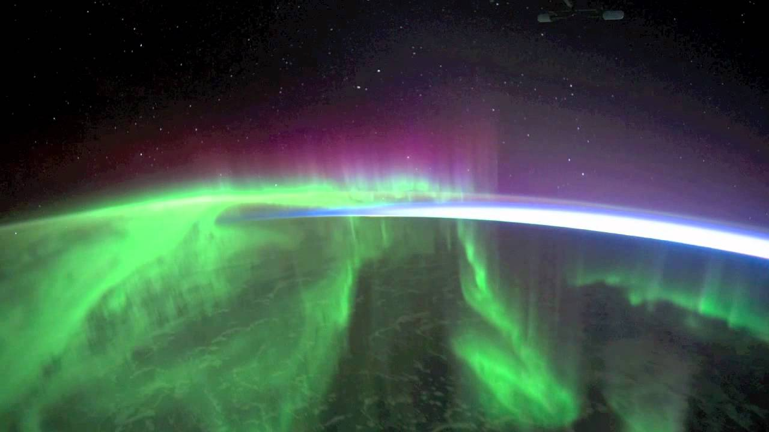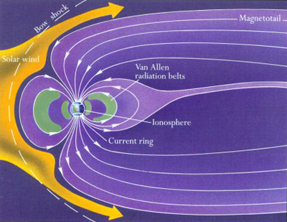Also what causes auroras by funneling charged particles into certain areas of the ionosphere
* This structure can generally be seen throughout the solar system

**Wind**

* The natural movement of air in response to variations in temperature from place to place
  + Strength of wind = magnitude of temp difference
* *Coriolis Effect*: effect of Earth’s rotation on winds
* *Hadley Circulation:* Air moving between the equator and poles of a planet in a pattern
  + These effects vary planet to planet
  + *Zonal Winds:* winds that blow predominantly east-west in relatively narrow bands of latitude
  + *Global Circulation:* The zonal pattern of several bands of alternating zonal winds lying between the equator and each hemisphere’s poles on Earth
    - Low pressure area of wind form circular cells called *cyclonic motion (hurricanes)*
    - Opposite of this is *anticyclonic motion*

**7.4: The Atmospheres of Venus and Mars Differ from Earth’s**

**Venus**

* Composed mainly of carbon dioxide, this vastly increases the greenhouse effect, trapping escaping radiation and heating the surface of Venus to over 700K
* Rotates very slowly, so no Corialis effect (Hadley effect at its finest)
  + This means everywhere on Venus is pretty much the same
* Rotates retrograde

**Mars**

* Very thin atmosphere, so highly subjective to change in temperature due to solar heating
  + This causes extreme changes in temperature, as well as more extreme seasons
* Also very small atmospheric pressure throughout
* Very windy